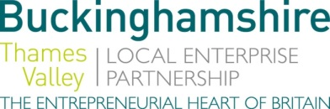

No. 026.18 26 September 2018

N E W S R E L E A S E
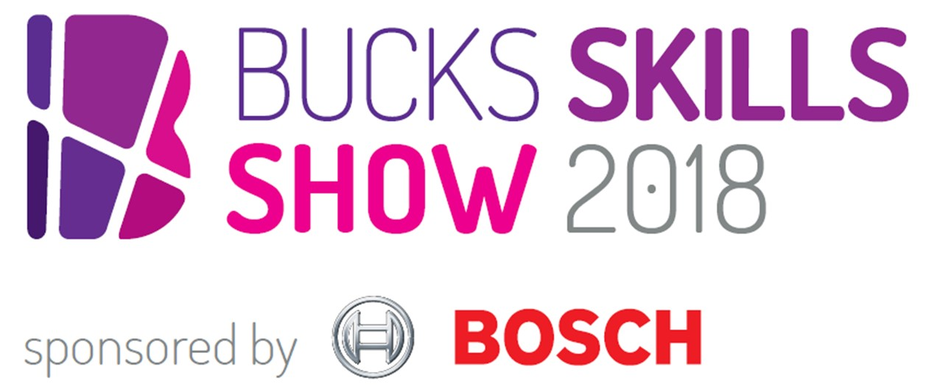
Discover new frontiers: careers exploration set for Bucks launch

Students, teachers, parents and businesses have begun the countdown to the launch of the Bucks Skills Show on Saturday 13 October – which this year features a new space industries area and a strong showing from the music trade.

Held at The Gateway in Aylesbury from 9.30am to 3pm, the county’s largest interactive careers fair is sponsored by Bosch and features other high profile exhibitors such as Jaguar Land Rover, the NHS, Pinewood Studios, General Electric and McAfee.

Event organiser Jackie Campbell from Buckinghamshire Skills Hub, part of Buckinghamshire Thames Valley Local Enterprise Partnership, explained: “Our mission is to open young people’s eyes to new opportunities and motivate them to achieve the best results possible at school by developing life goals early on. We’re expecting tickets to all go, so parents and students should sign up for free passes as soon as possible.”

more…

Discover new frontiers: careers exploration set for Bucks launch: 2

Speakers will also be sharing their career journeys and insider industry tips on the day, including representatives from Bosch, Google, the Ministry of Sound, ITV News and the Civil Service, plus Cabinet Office Minister and MP for Aylesbury David Lidington and Sir Anthony Seldon OBE.

Application Engineer Stephanie Alexander from event sponsor Bosch will be speaking on the day and highlighting potential careers in science, technology, engineering and maths. She said: “We’ll be engaging students by showcasing the variety of divisions that live under the single brand name of Bosch. From Bosch Mobility Solutions, to Industrial Technology, Bosch represents the Engineering, Technology and Manufacturing industry sector at the Bucks Skills Show and is proud to sponsor such an enlightening event for young people in the local area.”

Industry sectors represented at the Bucks Skills Show include:
- Creative (Film, TV and Music)
- Engineering, Technology & Manufacturing
- Life Sciences, Health & Social Care
- Business
- Retail, Hospitality & Leisure
- Space
- Civil Engineering & Construction
- Public Services
- Plus students can meet education providers at the ‘Next Steps’ area.

Search ‘Bucks Skills Show 2018’ on Eventbrite.co.uk to book free tickets for Saturday 13 October at The Gateway, Aylesbury, from 9.30am to 3pm. Follow @BucksSkillsShow on Twitter for updates.

Ends

Photo caption: From robot arms to augmented reality, gory stage make-up to a cyber-lock suitcase challenge, there are many discoveries to be made at the Bucks Skills Show sponsored by Bosch on Saturday 13 October.

Note to editors
The aim of BTVLEP’s Skills Hub – one of the first LEPs to develop such a hub – is to make a difference to young people’s employability while addressing the needs of employers. In Bucks, the level of employer engagement activity in schools can vary from school to school, and the Buckinghamshire Skills Hub is working to ensure all schools have access to effective and impactful employer interactions.

In order to help young people gain the valuable, constructive, rewarding work experience required, the Bucks Skills Hub has launched WANNABE (www.wannabebucks.org) where employers can post opportunities for young people to apply for. The site provides extensive information, guidance, a careerometer tool to explore earning potential and career prospects, as well as work experience, apprenticeship and part/full time job vacancies. Young people can look for work experience opportunities which are in line with their ambitions, rather than perhaps spending time at their parents’ place of work or finding placements via their parents’ network. There is a broad range of opportunities for young people to apply for.

The Buckinghamshire Thames Valley Local Enterprise Partnership (BTVLEP) is a business-led ‘partnership of equals’ between local government and the private sector, building the conditions for sustainable economic growth in the County. Formed in January 2012, the partnership balances a uniquely strong collective business voice with a cohesive elected local leadership. Coming together to engineer the conditions needed to drive forward business prosperity in the county and beyond, BTVLEP recognises that an important part of this is to support education and skills providers and employers to ensure our young people have the right skills to meet the needs of the economy, including the growth sectors such as life-sciences, space, creative industries and advanced engineering.

Buckinghamshire Business First (BBF), is the Growth Hub for Buckinghamshire and is backed by Buckinghamshire based entrepreneurs, thousands of SMEs and Local Authorities. BBF provides the link between public policy and the business community in Buckinghamshire and works with partners to create a dynamic business environment in the Entrepreneurial Heart of Britain.

For further information please contact:
Richard Burton
Communications Manager

T: 01494 568933
M: 07866 492292
E: richard.burton@btvlep.co.uk

