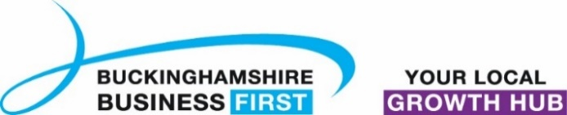
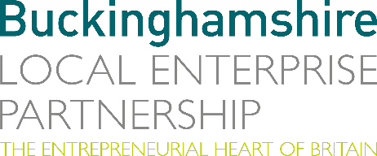
No. 010.21 5 May 2021
N E W S R E L E A S E

New Bucks business survey highlights challenging trading conditions
but also optimism

Buckinghamshire Local Enterprise Partnership and Buckinghamshire Business First have launched a new business survey to track business confidence and performance as the economy starts to recover from the shock of the Covid-19 pandemic.

The Buckinghamshire Business Barometer will be conducted quarterly and will help inform local and national economic policy.

The first survey, conducted between January and March 2021, shows just how tough trading conditions have been for local firms, with three quarters of respondents reporting that business conditions were ‘worse than normal’ for the time of year. The majority of firms responding to the survey experienced declines in profit, turnover, order books/ pipeline and sales in the first quarter of 2021. Overall, 85% of respondents said that they had be negatively impacted by the Covid-19 pandemic.

However, there are signs of optimism with a sizeable proportion of respondents reporting plans to invest in their business during the next quarter. 57% plan to invest in marketing and/ or advertising, whilst just under half of plan to invest in training and development, and in digital technologies (46% and 44% respectively). Furthermore, just over a quarter report plans to invest in equipment and/ or machinery. Encouragingly, more respondents plan to increase their employee headcount (24%) than to decease their headcount (8%).

more…

New Bucks business survey highlights challenging trading conditions: 2

Caroline Perkins, Research Manager at Buckinghamshire Local Enterprise Partnership, said: “I am delighted to introduce the first Buckinghamshire Business Barometer which aims to gauge local business confidence and performance as the economy emerges from the Covid-19 pandemic. It is testament to the entrepreneurial nature of businesses in Buckinghamshire that despite the major challenges over the past year, the results from this first report reflect the extent to which they have adapted to deal with the fall out of the pandemic.”

Any Buckinghamshire businesses who would like to participate in the next Barometer survey, can register their interest via info@bbf.uk.com. The full Buckinghamshire Business Barometer report can be downloaded at: www.buckstvlep.co.uk/useful-information/publications-reports/.

Ends

Note to editors

The Buckinghamshire Business Barometer is run by Buckinghamshire Business First and Buckinghamshire Local Enterprise Partnership. The Barometer began in 2021 and is conducted via an online survey on a quarterly basis. The survey can be completed by any business operating within Buckinghamshire and is promoted to businesses through Buckinghamshire Business First and its partners. Respondents are self-selecting and the results are not weighted, therefore the findings should be treated as indicative rather than representative of all Buckinghamshire businesses. The first Barometer survey (Q1 2021) was conducted between January and March 2021. The next survey (Q2 2021) will be conducted in May/ June 2021.

The Buckinghamshire Local Enterprise Partnership (Bucks LEP) is a business-led ‘partnership of equals’ between local government and the private sector, building the conditions for sustainable economic growth in the County.

Buckinghamshire Business First (BBF) is the Growth Hub for the county and is backed by Buckinghamshire-based entrepreneurs, thousands of SMEs, the Buckinghamshire LEP and Buckinghamshire Council. BBF provides the link between public policy and the business community in Buckinghamshire and works with partners to create a dynamic business environment in the Entrepreneurial Heart of Britain.

For further information, please contact:
Richard Burton
Communications Manager, Buckinghamshire LEP

T: 01494 927160
M: 07866 492292
E: richard.burton@btvlep.co.uk

