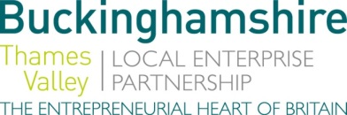

No. 017.18 4 July 2018
N E W S R E L E A S E
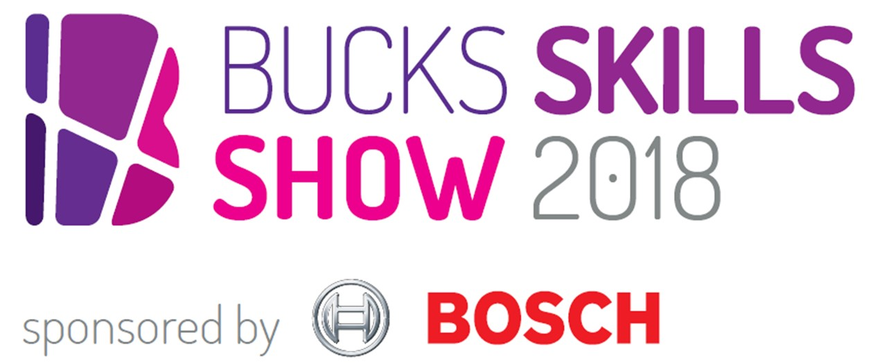
Bosch to “fuel imaginations” at Bucks Skills Show

The President of Bosch UK has announced the company’s aim to “fuel the imaginations of the brightest young minds” at the Bucks Skills Show 2018, the county’s largest interactive careers fair which takes place on Saturday 13 October at The Gateway in Aylesbury.

Steffen Hoffmann, President, Bosch UK, explained why Bosch is the event’s headline sponsor: “The UK is facing a critical shortage of new engineers entering the workforce, and the problem is made worse by the lack of women entering the profession. Young people have the ambition to solve problems and change the world, and the talent to deliver it. Our involvement with the Bucks Skills Show aims to shine a light on their potential capabilities and developing their skills - we want to fuel the imaginations of the brightest young minds by asking them to think how connectivity might transform our lives.”

Organised by Buckinghamshire Skills Hub, part of Buckinghamshire Thames Valley Local Enterprise Partnership, the county-wide careers event opens young people’s eyes to the many different job opportunities available, letting them meet employers face-to-face, experience the many activities on offer and be motivated by high profile guest speakers.
more…
Bosch to “fuel imaginations” at Bucks Skills Show: 2

Jackie Campbell, Skills Development Manager at Buckinghamshire Skills Hub, said the evidence for attending the event is compelling: “94% of people attending the Bucks Skills Show in 2017 said they now felt better informed to choose career or education next steps. It’s an opportunity for young people to discover their future and be inspired – and a unique chance to meet employers from Bosch to Pinewood Studios, the NHS to the InterContinental Hotels Group, McAfee to Tiggywinkles wildlife hospital all under the same roof.”

The Bucks Skills Show hosts employers from a range of industry sectors: public services; life sciences, health and social care; business; engineering, technology and manufacturing; media and creative; retail, hospitality and leisure. Students can also meet education providers at the ‘Next steps’ area.

Visit Eventbrite.co.uk to book free tickets for the event on Saturday 13 October at The Gateway, Aylesbury, from 9.30am to 3pm. Follow @BucksSkillsShow on Twitter for updates.

Ends

Photo caption: Students get their finger on the pulse of careers at the Bucks Skills Show thanks to Buckinghamshire Healthcare NHS Trust.

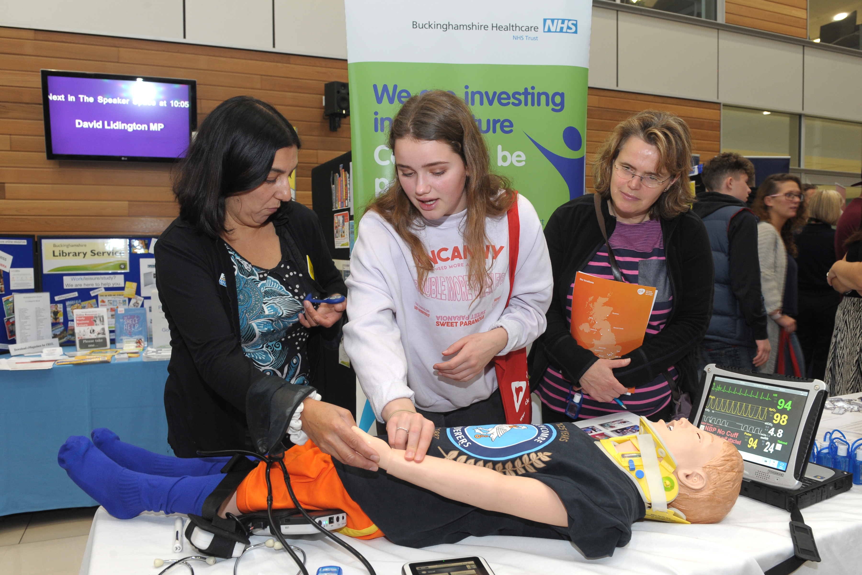
Note to editors
The aim of BTVLEP’s Skills Hub – one of the first LEPs to develop such a hub – is to make a difference to young people’s employability while addressing the needs of employers. In Bucks, the level of employer engagement activity in schools can vary from school to school, and the Buckinghamshire Skills Hub is working to ensure all schools have access to effective and impactful employer interactions.

In order to help young people gain the valuable, constructive, rewarding work experience required, the Bucks Skills Hub has launched WANNABE (www.wannabebucks.org) where employers can post opportunities for young people to apply for. The site provides extensive information, guidance, a careerometer tool to explore earning potential and career prospects, as well as work experience, apprenticeship and part/full time job vacancies. Young people can look for work experience opportunities which are in line with their ambitions, rather than perhaps spending time at their parents’ place of work or finding placements via their parents’ network. There is a broad range of opportunities for young people to apply for.

The Buckinghamshire Thames Valley Local Enterprise Partnership (BTVLEP) is a business-led ‘partnership of equals’ between local government and the private sector, building the conditions for sustainable economic growth in the County. Formed in January 2012, the partnership balances a uniquely strong collective business voice with a cohesive elected local leadership. Coming together to engineer the conditions needed to drive forward business prosperity in the county and beyond, BTVLEP recognises that an important part of this is to support education and skills providers and employers to ensure our young people have the right skills to meet the needs of the economy, including the growth sectors such as life-sciences, space, creative industries and advanced engineering.

Buckinghamshire Business First (BBF), is the Growth Hub for Buckinghamshire and is backed by Buckinghamshire based entrepreneurs, thousands of SMEs and Local Authorities. BBF provides the link between public policy and the business community in Buckinghamshire and works with partners to create a dynamic business environment in the Entrepreneurial Heart of Britain.

For further information please contact:
Richard Burton
Communications Manager

T: 01494 568933
M: 07866 492292
E: richard.burton@btvlep.co.uk

