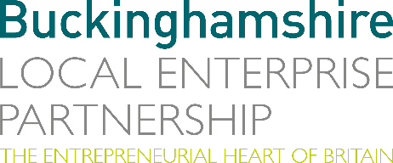

No. 034.19 23 October 2019

N E W S R E L E A S E
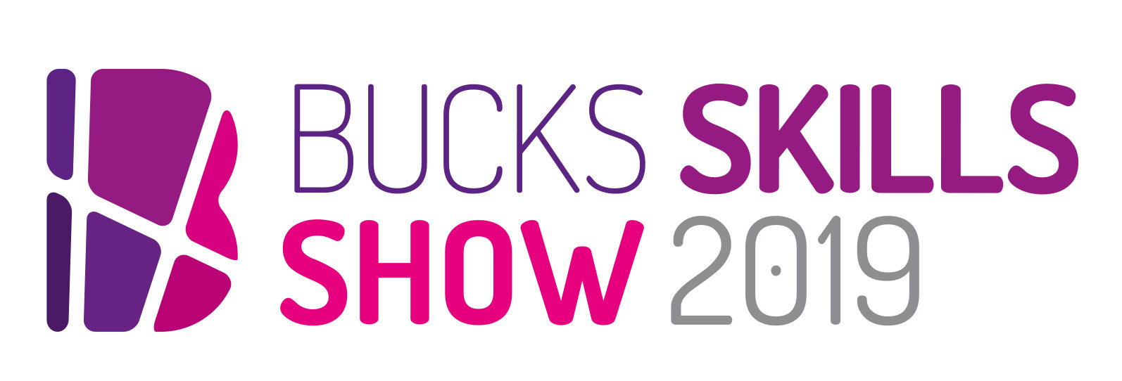
Sponsored by

Sell-out Skills Show welcomes 4000 visitors

Over 4,000 visitors poured through the doors of the Bucks Skills Show 2019 over two days last week (18 and 19 October) – increasing the number of students inspired about future career paths by a third compared to last year.

Students from 23 schools across Buckinghamshire and neighbouring areas benefited from meeting over 120 exhibitors and high-profile speakers across a wide variety of sectors – from creative companies to health and medical technology, public sector to space. Businesses ranged from global corporations such as Johnson & Johnson and Marriott Hotels to local businesses such as Monsta Pizza and Odds Farm Park.

Alison Lomax, Director of Retail at Google who spoke at the event, said: “I was blown away by the breadth of exhibitors from every walk of the careers spectrum – it was so beneficial for students and I’d love to return to represent the digital sector next year.”
more…

Sell-out Skills Show welcomes 4000 visitors: 2

Parents were equally enthusiastic, with one mum commenting: “My daughter thoroughly enjoyed the Bucks Skills Show and took away lots of valuable information and resources. As a parent it also helped me to understand the different paths she could take. We both came away very positive and enthused.”

Event organiser Marina Jackson from Bucks Skills Hub, part of Buckinghamshire Local Enterprise Partnership, summed up the event: “This year was undoubtedly a roaring success. Businesses, parents, students and teachers all told us how much they benefited from it, and we must say a huge thank you to our four major sponsors – Cube Video, Flannery Plant Hire, Buckinghamshire College Group and Bucks New University – for making it possible. My next task is to book in dates for 2020!”

Ends

Photo caption: Over 4,000 young people witness careers brought to life at the biggest ever Bucks Skills Show.

Note to editors
The aim of Bucks LEP’s Skills Hub is to make a difference to young people’s employability while addressing the needs of employers. Buckinghamshire Skills Hub is working to ensure all schools have access to effective and impactful employer interactions.

The Buckinghamshire Local Enterprise Partnership (Bucks LEP) is a business-led ‘partnership of equals’ between local government and the private sector, building the conditions for sustainable economic growth in the County. Formed in January 2012, the partnership balances a uniquely strong collective business voice with a cohesive elected local leadership. Coming together to engineer the conditions needed to drive forward business prosperity in the county and beyond, Bucks LEP recognises that an important part of this is to support education and skills providers and employers to ensure our young people have the right skills to meet the needs of the economy, including the growth sectors such as life-sciences, space, creative industries and advanced engineering.

Buckinghamshire Business First (BBF), is the Growth Hub for Buckinghamshire and is backed by Buckinghamshire based entrepreneurs, thousands of SMEs and Local Authorities. BBF provides the link between public policy and the business community in Buckinghamshire and works with partners to create a dynamic business environment in the Entrepreneurial Heart of Britain.

For further information please contact:
Richard Burton
Communications Manager

T: 01494 927160
M: 07866 492292
E: richard.burton@btvlep.co.uk

